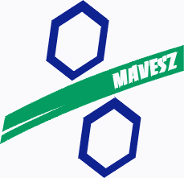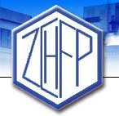
HUNGARIAN – SLOVAK CHEMICAL INDUSTRY FORUM
DRAFT PROGRAM
Budapest, 26 March 2013
Danubius Hotel Margitsziget (Spa & Health Resort), JazminConference Room

9.30-10.00 Registration

10.00 Opening of the Forum by the Co-Chairmen of the Conference:
Dr István Blazsek, President of MAVESZ & Mr Roman Karlubik, President of ZCHFP

10.15 Slovak-Hungarian Cooperation in the Petrochemical Industry – MOL Group
Mr Péter Plókai, Head of Group Polymer Product Sales, MOL Group

10.45 DUSLO, a.s member of Agrofert Group
Mr Ing. Mgr. Marek Štrpka, Managing Director, Duslo a.s.

11.10 Fortischem, a.s. member of EnergoChemica
Mr Ing. Juraj Píš, Managing Director, Fortischem,a.s.

11.35-12.00 Coffee break

12.00 More than 80 Years of Experiences in the Hungarian Fertilizer Industry:
Challenges, Opportunities and Innovation at Nitrogénművek Co.
Dr István Blazsek, General Manager, NitrogénművekZrt.

12. 20 Chemosvit group – innovation is our future,
Mr Ing. Michal Ľach, President of the Board

12.45 – 14.00: Buffet lunch

14.00 PPP SPIRE:European Industrial Competitiveness through Resource and Energy Efficiency- Why to be a member of this partnership?
Dr Frantisek Doktor, senior consultant, European Chemical Industry Council

14.25 EU regulations (REACH, biocides, crop protection) and their impact on the market positions of a Hungarian chemical producer SME
Mrs Borbála Otto, Commercial Director, Agroterm Kft.

14.50-15.15 Coffee break

15.15 Industrial Intermediate and Consumer Chemicals Production – SME experience by MATERIÁL Chemicals Cooperative(working title)
Mr Márton Csaszny, Chairman of METERIÁL Chem. Coop.

15.40 Closure of the Forum by the Co-Chairmen

